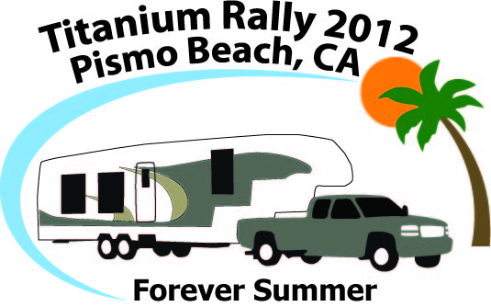 | Thursday April 19th – Monday April 23nd  Pismo Coast Village RV Resort  165 S. Dolliver  Pismo Beach, CA  (888)782-3224  www.pismocoastvillage.com

Registration is NOW open!!!

The Registration Form can be accessed at http://www.titaniumrvowners.com/rallies.htm but here are the details:

Required Costs - Rally price = $182.04 (2 nights at $44.40 [TH/SU] + 2 nights at $46.62 [FR/SA])
Event fee = $ 25.00 per reservation
TOTAL = $207.04

Optional Costs – Saturday Matinee theater show at $18 per person. See www.americanmelodrama.com
Pets - $2.00 per night
Additional person - $2.00 per night (over two people)
Logo hats = $ 18.00 each
Logo tee shirts = $18.00 each (unless XXL)
Logo jackets = $39.00 each (unless XXL)
Name badges - badge is either $7.75 or $10.50 depending on style, tags are $4.00 ea (paper name badges are included with registration)

Additional nights may be booked at the rally price but must be reserved with your rally reservation.

Important: If you would like to update your picture for the rally booklet or if you have never sent one, please send your picture to Bob Kendall at bobkendallgb@gmail.com by March 19st.

Important: We will be creating a recipe book again this year. Please send your recipes for the potluck appetizers and the BBQ potluck to Pamela Gedalia at skalamo@aol.com by April 3rd or you can call her at (818)398-4158.

Cancellation Policy - Any cancellation before March 19, 2012 will receive a full refund minus $10 resort processing fee. For cancellations between March 19, 2012 and 10 days prior to the start of your reservation, any paid event fee and optional fees will be withheld to cover committed expenses, including the $10 resort processing fee. There will be NO refund within 10 days of the start of your reservation. In other words, you will forfeit your entire reservation (resort policy).

